ABC Company
Network Infrastructure Design Proposal
ISAN 3348.251
Written by:
Jackson Allen, Troy Eloff, and Justin Reyes

Assumptions
The following assumptions were made in developing this network design proposal. Each is documented to support the justifications provided in subsequent sections.

Growth Model
- The company-wide growth rate of 12% annually for Years 1 through 3, followed by 9% annually from Year 4 onward, is applied to employee headcounts and host counts for all departments.
- The department-specific annual growth rates provided in the project specifications apply exclusively to throughput projections, as these rates vary significantly by department and are inconsistent with a uniform company-wide headcount growth pattern.
- Host counts per department are calculated proportionally from employee counts using the ratio of total hosts to total employees (389/348), consistent with the project specification that employees are distributed proportionally to hosts.
- Growth is applied independently per department and rounded to the nearest whole number for each projection year.

Space and Occupancy
- The 20% work from home rate is applied across all departments.
- Support makeup 10% of each department's total count and is included within that count, per the project specification.
- All five floors of each building are active from Year 0 to distribute current occupants more evenly and reduce per-floor density, while keeping floors 4 and 5 lighter to accommodate projected growth.
- The 30% common space allocation covers walkways, restrooms, breakrooms, wiring closets, and elevator shafts, and is applied across all floors.
- Administrative personnel are assigned office spaces at 240 square feet per person. All other employees occupy standard cubicles at 122 square feet, and support staff occupy cubicles at 100 square feet.
- For the purpose of infrastructure and cabling calculations, assume each building's floor ceiling height is 10 feet.

Network and Infrastructure
- The HP 5830 switches provided by the IT department are used as the main Layer 3 switches in the network design. One HP 5830 switch is placed on Floor 1 of each building and is used for inter-VLAN routing and backbone connectivity between floors. Each switch reserves 2 ports for uplink connections, leaving 46 ports available for devices and floor access switches.
- VoIP phones are installed at every workstation and act as 2-port switches. This allows both the computer and phone to use the same Ethernet drop while still separating voice and data traffic through VLANs. This setup helps reduce extra cabling throughout the buildings.
- The conference room located on Building A Floor 1 includes wired Ethernet connections and a Netgear WNDAP620 wireless access point to support VoIP and video conferencing. The wireless access points are powered using PoE from the floor access switches, so separate power outlets are not needed for each AP.
- A Netgate 6100 MAX running pfSense+ is used as the company’s main firewall and edge router. It handles NAT/PAT, VLAN traffic control, VPN support, traffic filtering, and secure Internet access between the company network and the ISP connection.

Building Topology

Building A
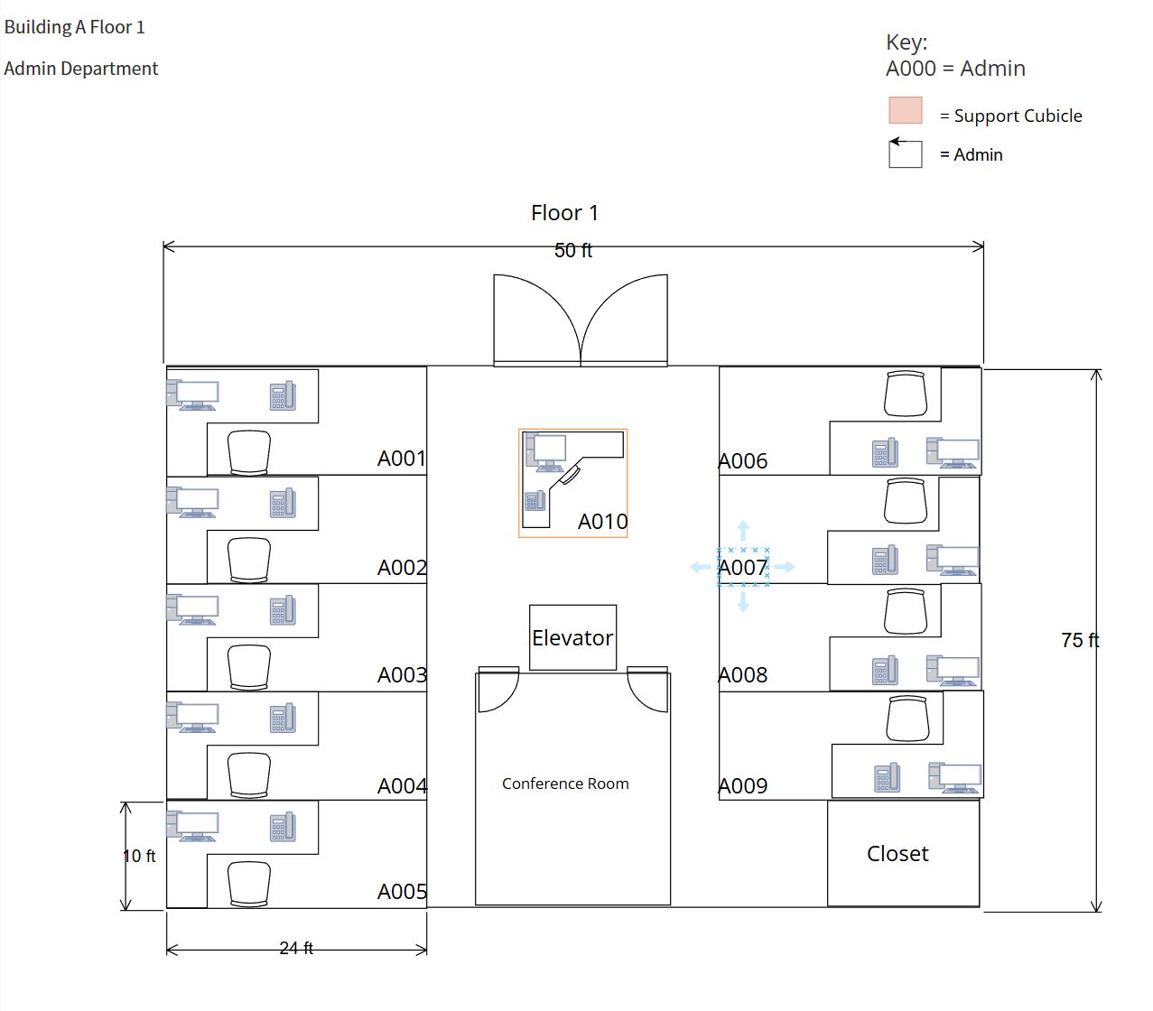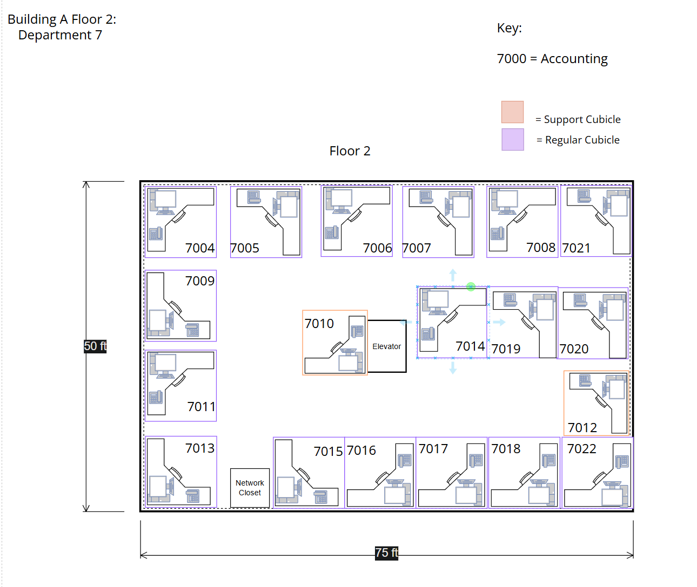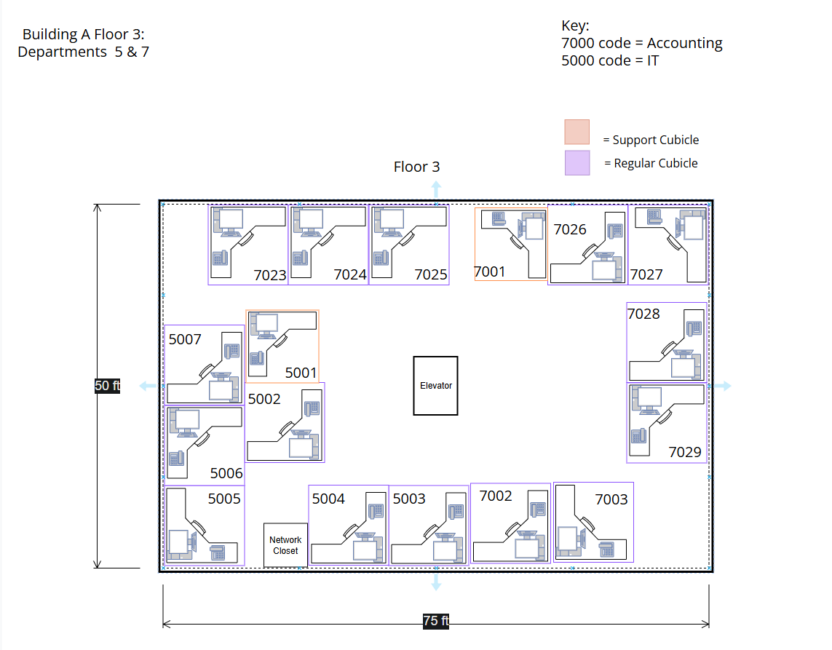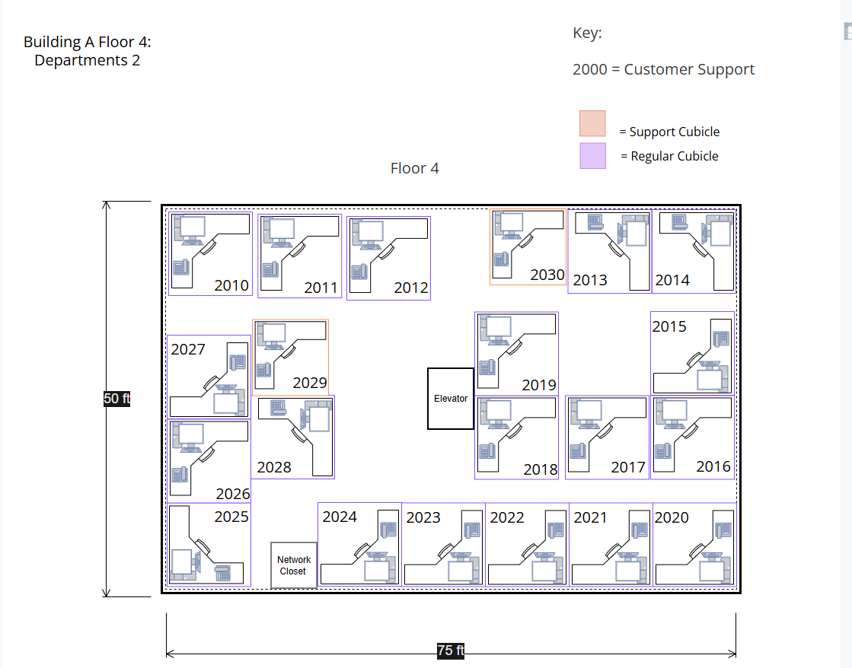
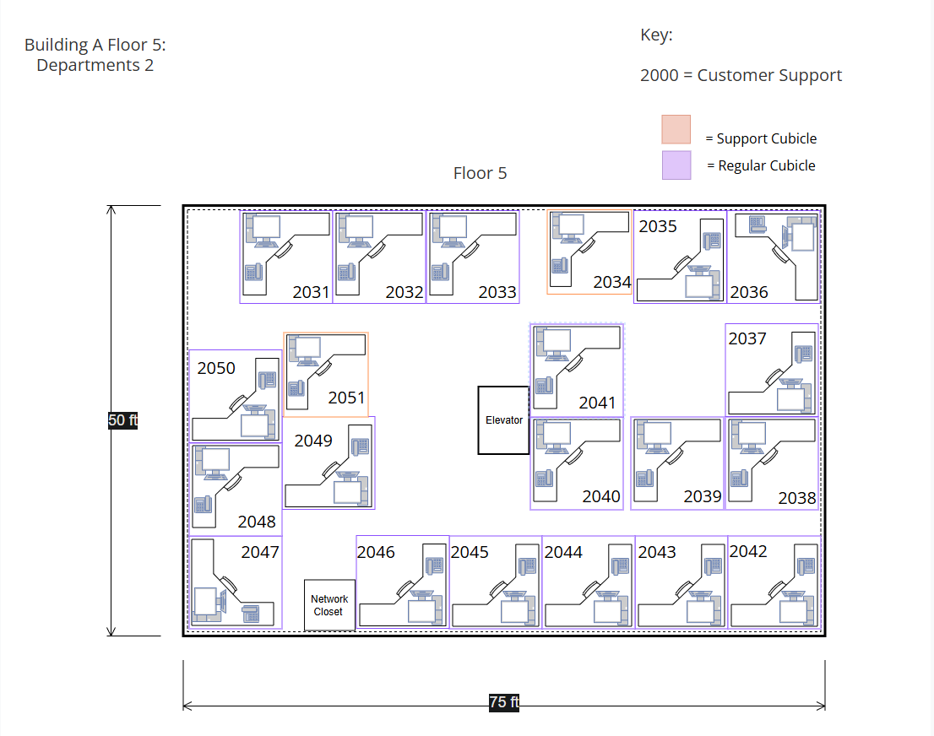

Building B
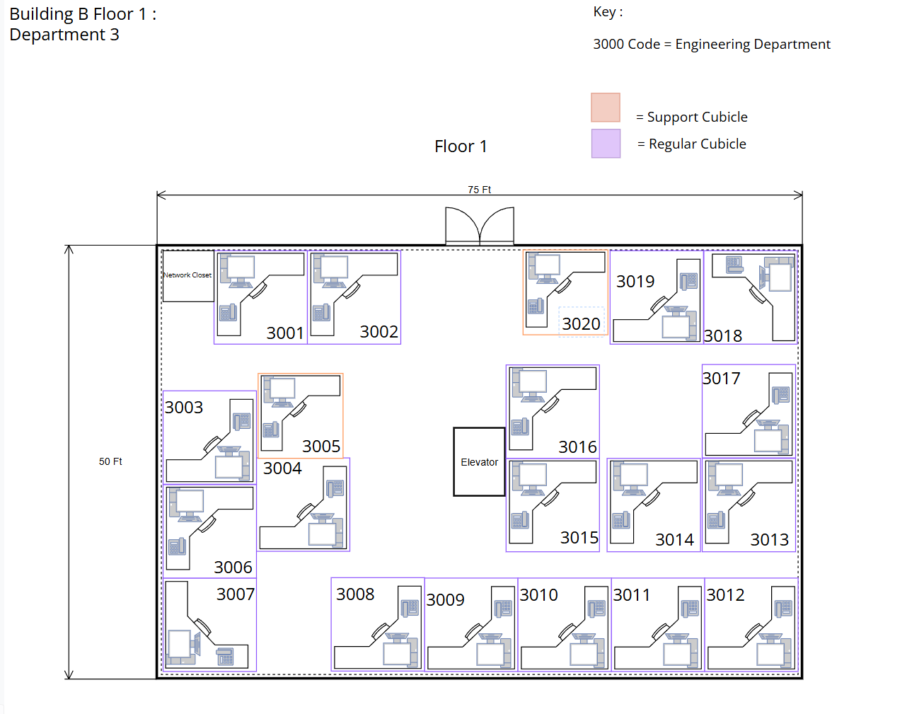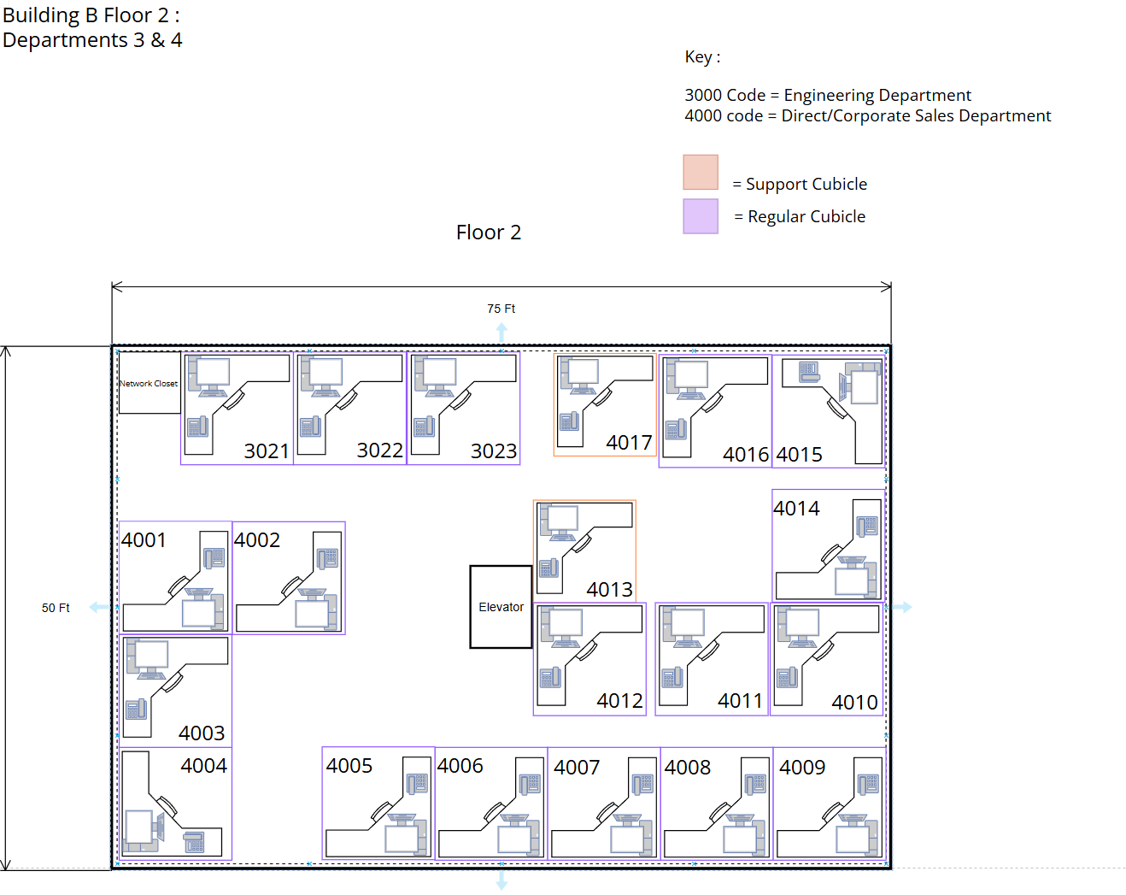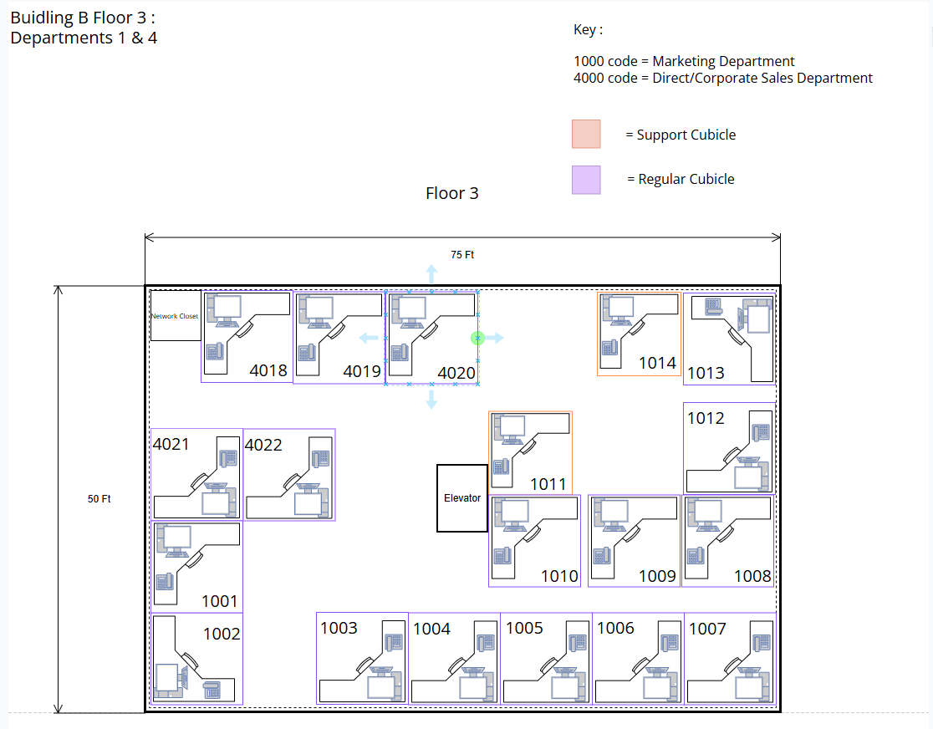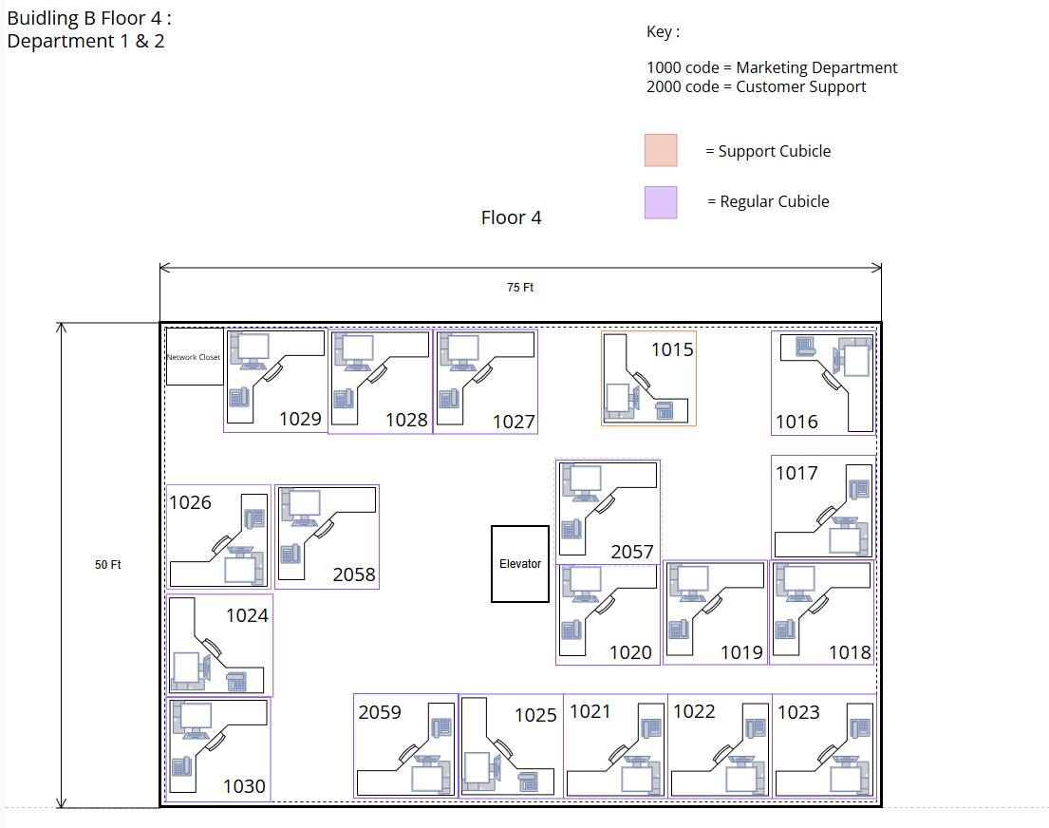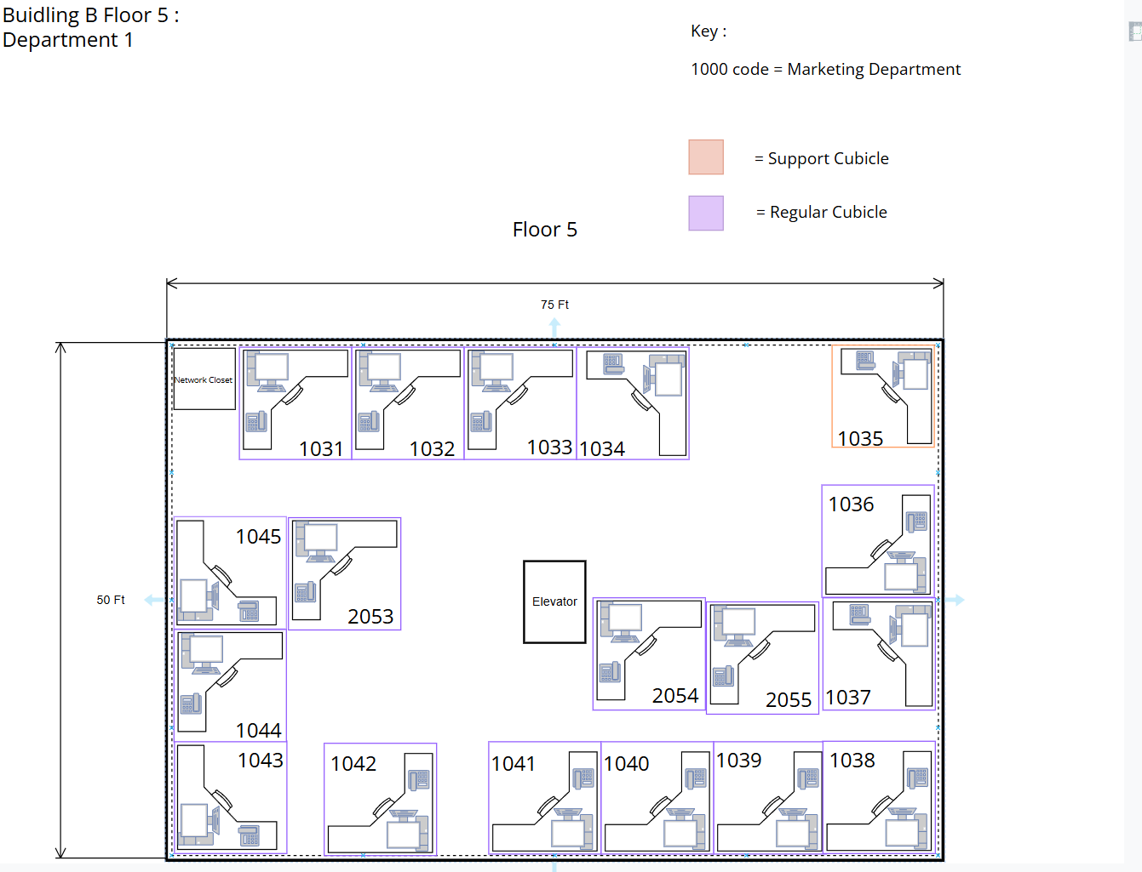

Building C

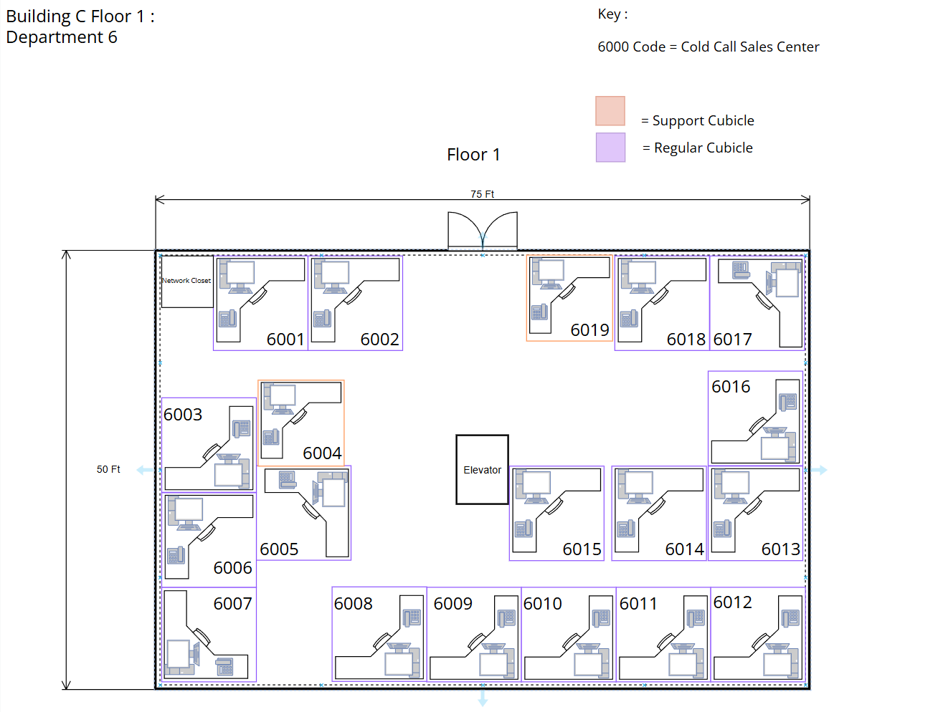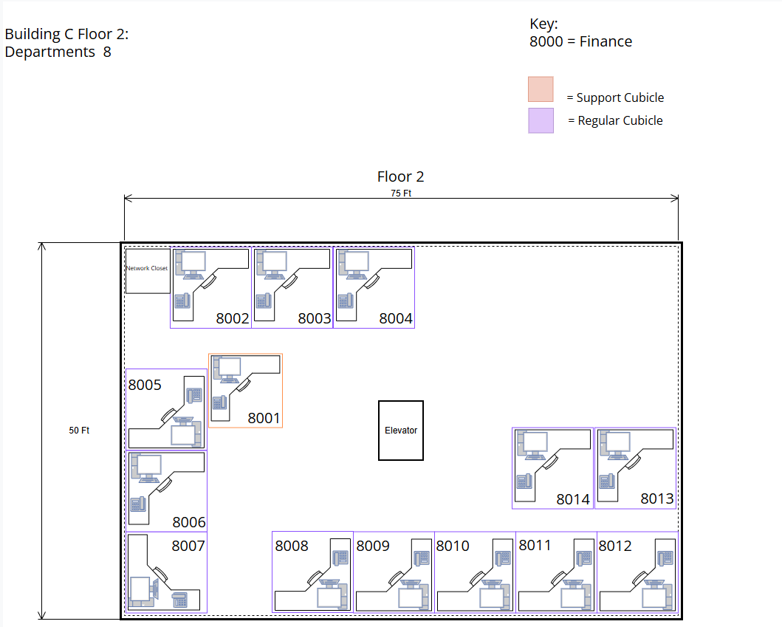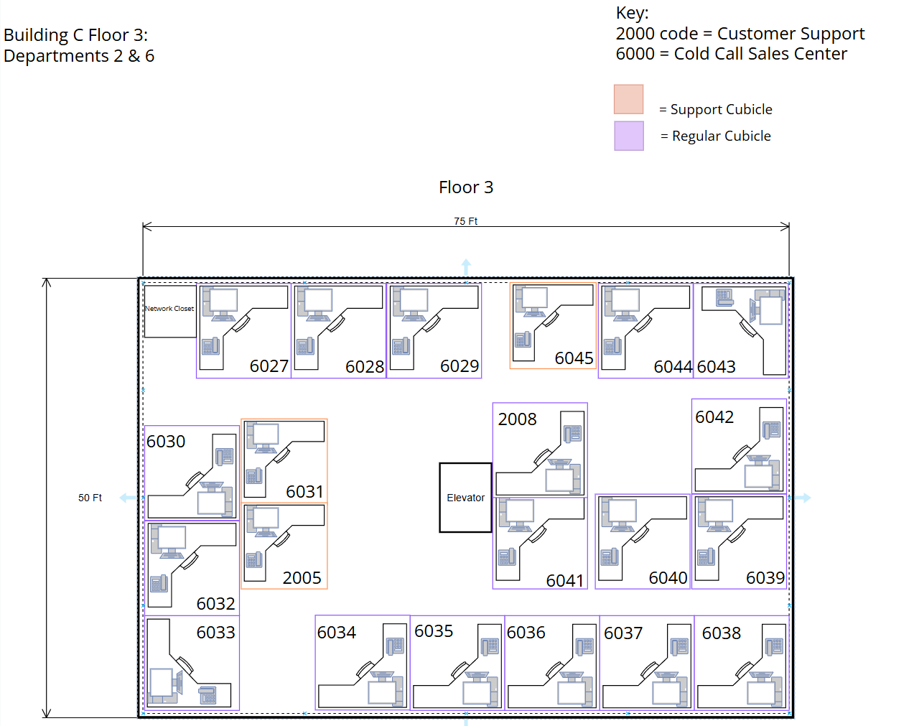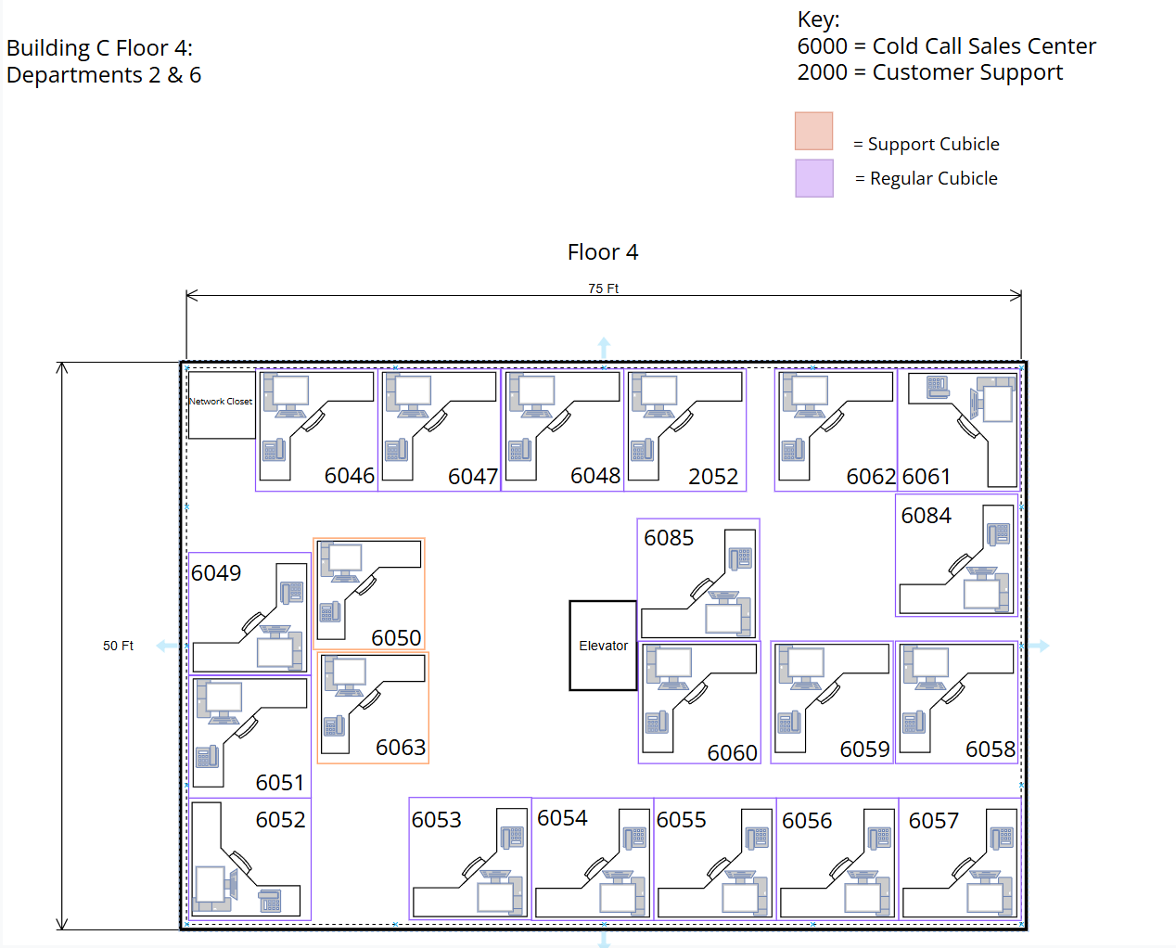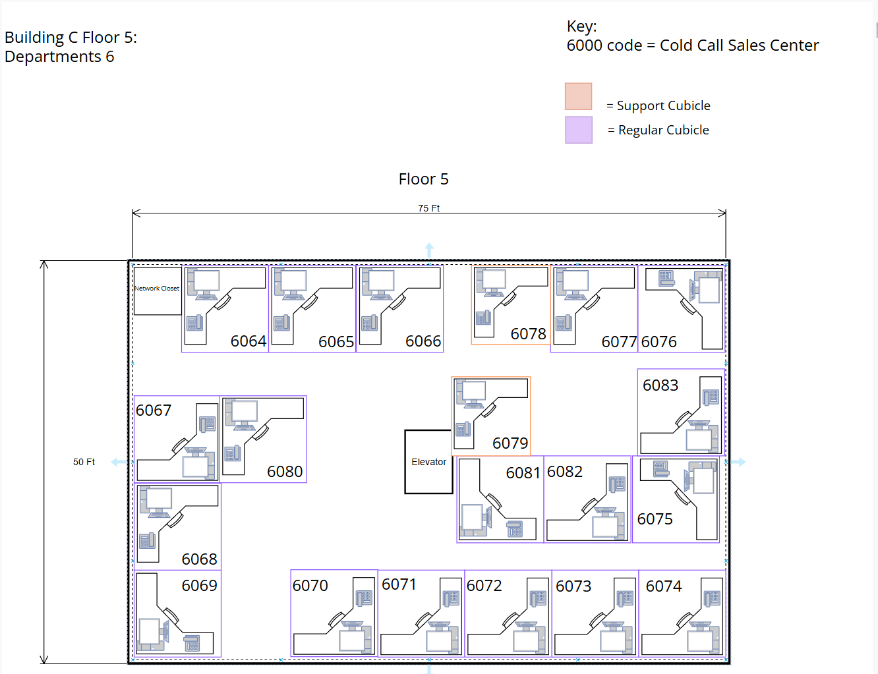

Building A Topology
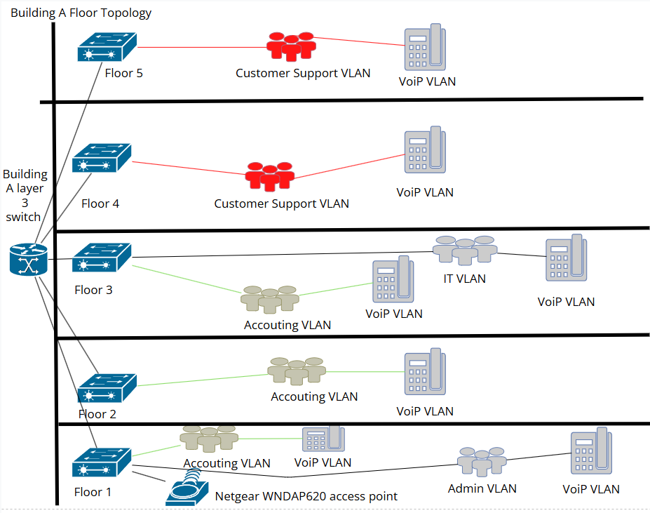
Building B Topology
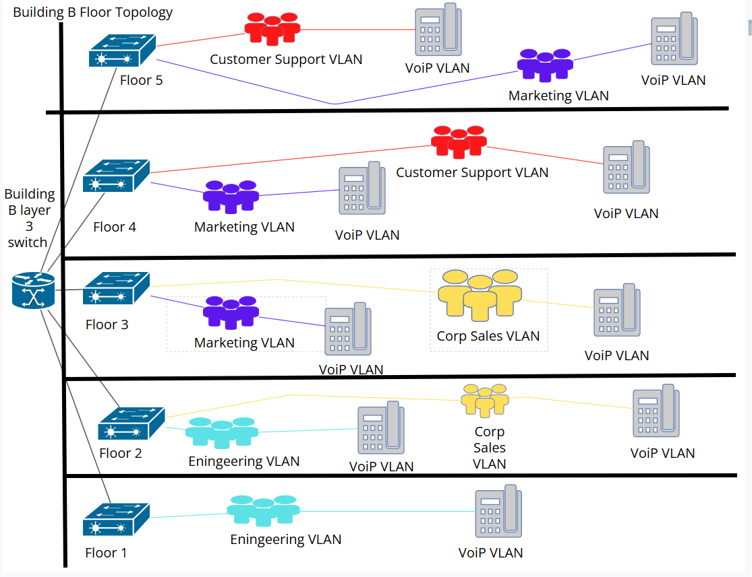
Building C Topology

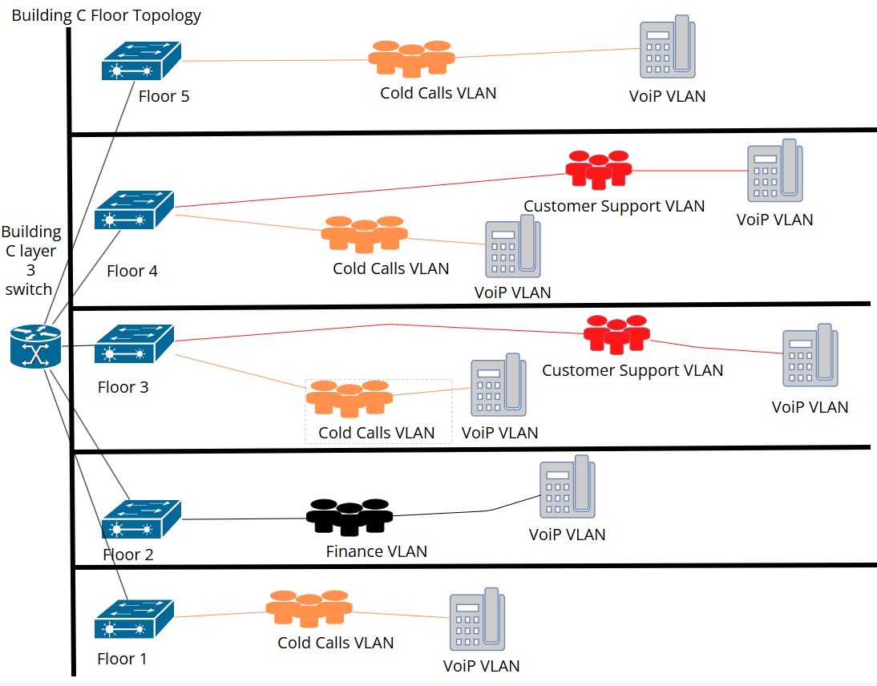

IP Addressing Scheme
Option 1 from the project specification was selected: a single public IPv4 address at $500 per year. Internally, the company uses private addressing with Network Address Translation (NAT) handled at the firewall and router (Netgate 6100 MAX pfSense+ Security Gateway).

Justification
Using a single public IPv4 address with private internal addressing is the most cost effective option for a company this size. ABC Company does not host public services or need every device to be directly accessible from the Internet, so purchasing a large range of public IP addresses under Option 2 would add unnecessary cost. IPv6 was also considered, but the IPv4 solution combined with private internal addressing is enough to support both the company’s current network and future growth while keeping costs lower.
The internal network uses the private 10.0.0.0/8 address range with a company-wide 10.10.0.0/16 subnet structure. This gives the company over 65,000 possible host addresses, which provides more than enough room for future buildings, departments, VLANs, and network expansion without needing to redesign the addressing scheme later.

VLAN and Subnet Assignments
Each department is assigned a dedicated VLAN and corresponding /24 subnet, providing 254 usable host addresses per department. This isolates broadcast domains, improves security, and allows each department to scale independently for ABC's expected growth.

Department | VLAN | Subnet | Notes
Admin | 10 | 10.10.10.0/24 | Administrative offices, Building A
Accounting | 20 | 10.10.20.0/24 | Buildings A and B
Engineering | 30 | 10.10.30.0/24 | Building B
Marketing | 40 | 10.10.40.0/24 | Building B
Customer Support | 50 | 10.10.50.0/24 | Buildings A, B, and C
Cold Call Sales | 60 | 10.10.60.0/24 | Building C
VoIP (all depts) | 70 | 10.10.70.0/23 | /23 used to support 279+ on-site phones
Finance | 80 | 10.10.80.0/24 | Building C
IT | 90 | 10.10.90.0/24 | Building A
Servers / DMZ | 99 | 10.10.99.0/24 | Core infrastructure, Building A MDF

The VoIP VLAN uses a /23 subnet providing 510 usable addresses rather than the standard /24, as the 279 current on site employees would exceed a /24 limit of 254 addresses when accounting for projected growth.

Inter-Building Connectivity

Structure
The three buildings are interconnected in a STAR topology: Building A connects to Building B, and Building A connects to Building C. Building A Floor 1 houses the sole MDF, which serves as the network core for the entire ABC company and contains the core router, firewall, and internet uplink. Buildings A, B, and C each contain a Layer 3 distribution switch on Floor 1 that aggregates floor level traffic and uplinks to the MDF in Building A over the inter building fiber backbone.
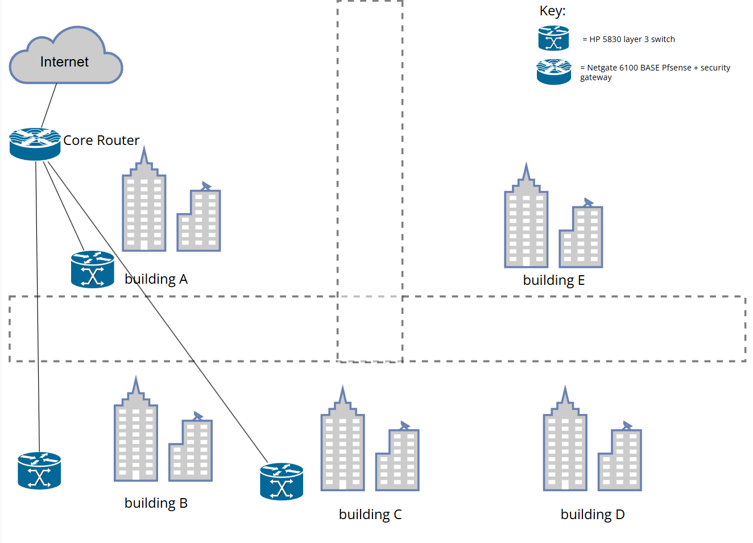

Department and Employee Allocation

Security Constraint
The project specification identifies Engineering, Finance, Accounting, and Administration as security sensitive departments that must not be co-located with the Cold Call Sales Center or Customer Support. This constraint was the primary driver of the building assignment decisions.

Building Assignments
Building A houses Administration on Floor 1, Accounting on floors 2 and 3, and IT on floor 3, with Customer Support occupying floors 4 and 5. Floor 1 is dedicated to Administration and includes a conference room provisioned for video conferencing. The Accounting team was consolidated onto floors 2 and 3 to free up the necessary space on floor 1. Administration and Accounting are logically grouped given their shared security sensitivity, and IT's placement in the same building simplifies infrastructure management. Customer Support was assigned to floors 4 and 5 as overflow, separated from the Cold Call Sales Center in Building C.

Building B houses Engineering, Corporate Sales, and Marketing departments. These departments were grouped together to simplify departmental organization, support future growth, and balance employee distribution across the campus while minimizing unnecessary inter-building traffic where possible. Accounting overflow occupies a portion of Floors 4 and 5.

Building C houses the Cold Call Sales Center, Finance, and Customer Support overflow. Cold Call Sales is the largest department by headcount and occupies the majority of all five floors. Finance, as a security-sensitive department, is solely assigned to floor 2 and isolated from the call center floors through VLAN segmentation.

Five-Floor Distribution
All five floors of each building are utilized beginning in Year 0 to maintain balanced employee distribution and keep floor utilization within the 70 percent usable space limitation. Distributing departments across all floors also improves traffic flow, reduces overcrowding, and simplifies network and infrastructure deployment throughout each building.

Hardware Selection and Location

Switches: HP 5830
The HP 5830 48 port Gigabit Layer 3 switch was specified by the IT department as the standardized platform for the deployment. A single switch model across the entire installation minimizes spare parts inventory, simplifies technician training, and reduces ongoing maintenance overhead. The Layer 3 capabilities of the HP 5830 switches support inter-VLAN routing at the distribution layer, reducing traffic load on the core router. Access layer 2 switches are deployed within each floor IDF, while a centralized HP 5830 Layer 3 switch located on Floor 1 of each building provides backbone routing and inter-floor connectivity as part of the routed backbone topology.

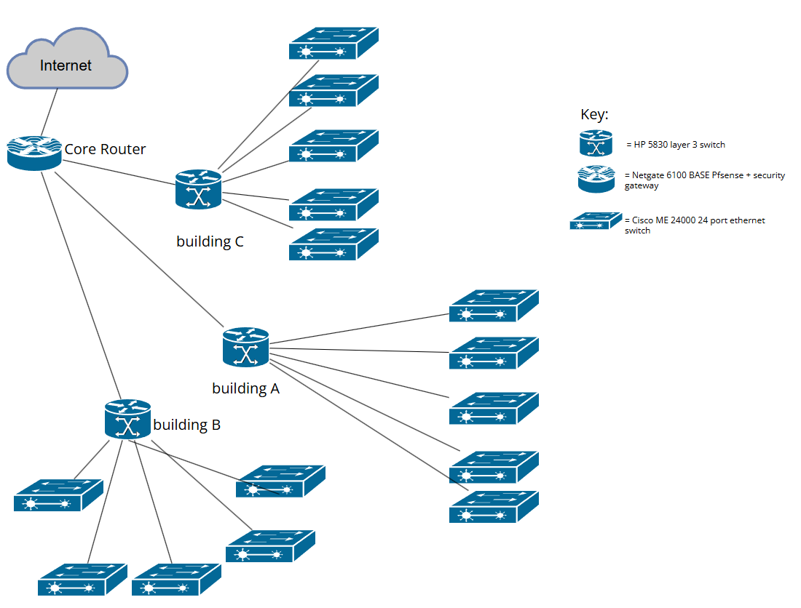

Firewall and Router: Netgate 6100 pfSense
The Netgate 6100 running pfSense+ is used as the main firewall and WAN gateway for the company network. It is located in Building A at the MDF and connects the internal network to the ISP connection and core switch infrastructure. The device handles NAT, firewall filtering, VLAN traffic control, and WAN connectivity for all buildings. Using the Netgate 6100 for both routing and firewall services helps reduce hardware costs while keeping the network design simpler and easier to manage. pfSense also provides security and networking features that fit the company’s current size while still allowing room for future growth, including support for VPN connectivity, traffic management, and additional scalability options.

Wireless Access Points: Netgear WNDAP620
The Netgear WNDAP620 is the standardized wireless access point used throughout the deployment, as specified by the IT department. The unit is ceiling mounted in the conference room to support VoIP and video conferencing connectivity. All access points are powered through PoE from the floor level access switches, eliminating the need for separate electrical power drops at each access point location.

MDF and IDF Locations
The sole MDF is located in Building A on Floor 1 and serves as the network core for the entire company. Each building has a Layer 3 distribution switch on Floor 1 that aggregates traffic from to each floor with a Layer 2 access switch and connects back to the MDF in Building A via the inter-building fiber backbone. Each floor has a dedicated IDF in the wiring closet located on the wall closest to the main road, per the building layout specified in the project.

Cable Installation
Cabling was selected based on the distance and performance requirements at each part of the network. Fiber optic cable is used to connect the three buildings together in a star topology through Building A because the buildings are around 200 feet apart and the underground road crossings make UTP less practical for inter-building connections. Building A Floor 1 uses fiber connections since it contains the MDF and main backbone equipment. All other floors use Cat6 UTP cabling to connect employee workstations to the floor access switch because it is cheaper and still supports the required network speeds within normal building distances. VoIP phones are connected in-line between the wall port and workstation, allowing one cable drop to carry both voice and data traffic on separate VLANs.
This design helps lower overall installation costs by only using fiber where high bandwidth and longer distance connections are actually needed. Using Cat6 UTP for workstation connections keeps the network more affordable while still giving enough performance and room for future company growth

Scalability and Future Growth
The network design is structured to accommodate ABC Company's projected growth over a five-year horizon and beyond without requiring fundamental redesign.

- The 10.10.0.0/16 internal addressing scheme provides sufficient address space for Buildings D and E when they come online. New buildings will be assigned VLAN ranges from the reserved 100 to 199 block.
- The HP 5830 switch platform supports stacking and additional modules, allowing port capacity to be expanded on existing floors before new switches are required.
- The inter-building fiber conduit is sized to accommodate additional fiber strands for future 10 GbE upgrades or redundant paths.
- Floors 4 and 5 in each building are intentionally under-occupied at Year 0, providing immediate physical space for headcount growth without floor plan modifications.

